Online Shopping Management System – Project Case Study
Nov 3, 2026 · @Ashu

1. Project Overview
This case study asks learners to build ShopSmart, a small online shopping system with two entities, Product and Order. It is delivered as one Spring Boot application with a React SPA / Angular front end, and it is the Weeks 5–7 project for the Java Full Stack course.
Business context. A small retailer takes orders by phone and tracks stock in a spreadsheet. Stock counts drift and orders get lost. ShopSmart lets customers browse products and place orders online, and lets staff manage products and move orders through their statuses, with MySQL as the single source of truth.
Simplifications made on purpose
- No login, no roles and no Spring Security: every screen and endpoint is open. This keeps the focus on Spring Boot, Hibernate and REST.
- Two tables only: products and orders. One order is for one product and a quantity.
- Payment and delivery are not modelled; an order carries the customer's contact details and shipping address as plain columns.
Why a monolith. One codebase, one build, one database and one deployment unit keep the project learnable in three weeks. A single @Transactional method can reduce stock and save the order together, and debugging happens in one IDE session.
Learning outcomes. By the end, a learner can:
- Design a layered Spring Boot application (controller, service, DAO, entity).
- Design two related MySQL tables and map them with Hibernate (SessionFactory, Session and HQL).
- Build a validated REST API with consistent error responses.
- Build a React SPA / Angular app that consumes that API.
- Test the API in Postman and the service layer with JUnit and Mockito.

2. Problem Statement, Objectives and Scope
Problem. Orders arrive by phone and are written in a spreadsheet. Nobody can see current stock, orders are lost or double-booked, and customers cannot check their order status.
Objectives
- Let anyone browse and search products and place an order online.
- Keep stock accurate: an order can never take stock below zero.
- Let staff add, edit and remove products and see all orders.
- Let staff move an order from PLACED to SHIPPED to DELIVERED, or cancel it.
- Expose a documented REST API used by the React SPA / Angular app and by Postman.
 | In scope | Out of scope
Products | Create, read, update, delete, search, pagination | Categories, images, reviews
Orders | Place, list, view, cancel, update status | Multiple products per order, returns
Users | None; all screens are open | Registration, login, roles, JWT
Payment and delivery | Not modelled | Payment gateway, courier tracking
Platform | One Spring Boot app, MySQL, React SPA / Angular | Microservices, message brokers, Docker
Hint: if a learner finishes early, the stretch goals in section 14 add order items, login and roles in that order.

3. Functional Requirements
Each requirement has an acceptance check that a learner can demonstrate in Postman or in the UI.
ID | Module | Requirement | Acceptance check
FR-01 | Product | Add a product with name, description, price and stock quantity | Valid request returns 201; blank name or negative price returns 400
FR-02 | Product | List products with search by name, sort and pagination | GET /api/products?q=mouse&page=0&size=5 returns a page object
FR-03 | Product | View, update and delete a product | Unknown id returns 404; deleting a product that has orders returns 409
FR-04 | Order | Place an order for one product with quantity, customer details and address | Returns 201 with status PLACED and the calculated total
FR-05 | Order | Stock is reduced in the same transaction that saves the order | If stock is too low, no order is saved and stock is unchanged (409)
FR-06 | Order | The order stores the unit price at purchase time | Changing the product price later does not change old orders
FR-07 | Order | List orders with an optional status filter, newest first | GET /api/orders?status=PLACED returns only PLACED orders
FR-08 | Order | View one order with its product name | Unknown id returns 404
FR-09 | Order | Update status along PLACED, SHIPPED, DELIVERED | An invalid jump such as DELIVERED to PLACED returns 400
FR-10 | Order | Cancel an order while it is PLACED; stock is returned | Stock increases by the order quantity; SHIPPED orders cannot be cancelled
FR-11 | Platform | Every error uses one JSON format | Matches the format in section 8
Order status flow: PLACED → SHIPPED → DELIVERED. CANCELLED is reachable from PLACED only and is final.

4. Non-Functional Requirements
Area | Requirement
Performance | Product list responds in under 500 ms with 1,000 seeded products; list endpoints are always paginated
Data integrity | Foreign key from orders to products, CHECK constraints on price and stock, and @Transactional on every write that touches both tables
Concurrency | @Version on Product so two simultaneous orders cannot both take the last unit
Maintainability | Layered packages, DTOs separate from entities, constructor injection, no business logic in controllers
Testability | Service rules covered by JUnit 5 and Mockito; every endpoint covered by a Postman test
Usability | Responsive React SPA / Angular UI that works at phone width; clear loading and error states
Portability | Runs with mvn spring-boot:run and a local MySQL; configuration in application.properties
Documentation | README with setup steps, table diagram and API list

5. Technology Stack
The stack is fixed by the course. Use either React or Angular for the front end; the same screens, routes and API calls apply to both.
Layer | Technology | Used for
Language | Java 17 or 21 (LTS) | Back-end code; records for DTOs, var, text blocks
Framework | Spring Boot 3.x | Auto-configuration, embedded Tomcat, dependency management
Web | Spring Web (Spring MVC) | @RestController, request mapping, @RestControllerAdvice
Validation | Bean Validation (spring-boot-starter-validation) | @NotBlank, @Min, @Email on request DTOs
Persistence | Hibernate ORM (native Session API and HQL) | Entity mapping, DAOs, HQL queries, transactions
Database | MySQL 8 | Two tables, constraints, indexes
Front end | React SPA (React 18, Vite) or Angular 17+ | Single-page UI, routing, forms
Web basics | HTML5, CSS3, JavaScript (ES6+) or TypeScript | Markup, styling, API calls
Build | Maven | Build and package as one runnable JAR
API testing | Postman | Collections, environment variables, test scripts
Unit testing | JUnit 5, Mockito | Service-layer tests with mocked DAOs
IDE | IntelliJ IDEA or Eclipse | Development, debugging, database view
Hint: generate the project at start.spring.io with Spring Web, JDBC API, MySQL Driver and Validation, then add hibernate-core and spring-orm to the pom.xml. Do not add Spring Data JPA. Do not add Spring Security; it would put a login page in front of every endpoint.

6. Monolithic Architecture
ShopSmart is one Spring Boot application packaged as a single JAR. The React SPA / Angular app and Postman call the same REST API; each request passes the same layers and ends in one MySQL schema.
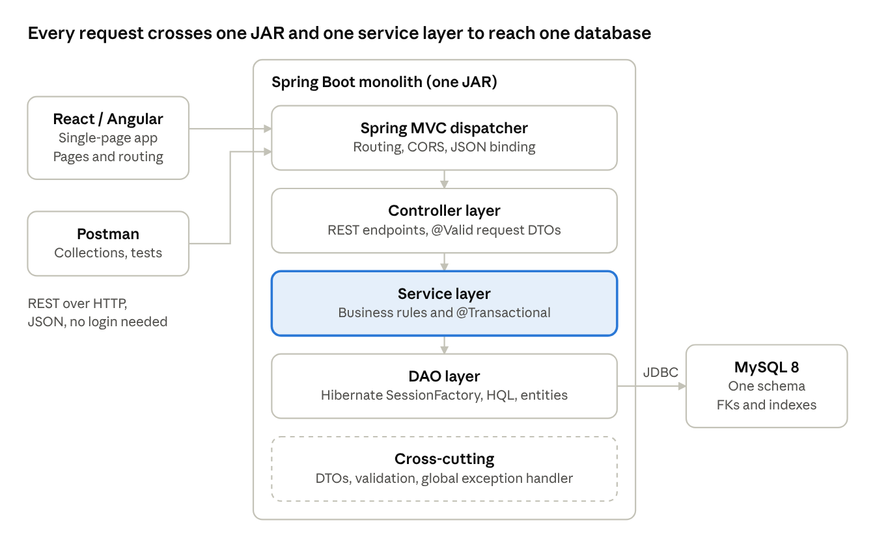
ShopSmart monolith · 4 layers, 1 database
The highlighted service layer holds the business rules and transaction boundaries; controllers and DAOs stay thin.
Request flow: placing an order
- The React SPA / Angular client sends POST /api/orders with a JSON body.
- OrderController validates the request DTO (@Valid) and calls OrderService.placeOrder(...).
- Inside one @Transactional method, the service loads the product, checks stock, reduces it, and saves the order.
- Hibernate issues the UPDATE products and INSERT orders statements; any exception rolls both back.
- The controller returns 201 Created with an OrderResponse DTO.
Package structure
com.annotatetech.shopsmart
├── ShopSmartApplication.java
├── config/ CorsConfig, HibernateConfig
├── controller/ ProductController, OrderController
├── service/ ProductService, OrderService
├── dao/ ProductDao, OrderDao
├── entity/ Product, Order, OrderStatus (enum)
├── dto/ ProductRequest, ProductResponse, PlaceOrderRequest, OrderResponse
└── exception/ ResourceNotFoundException, OutOfStockException, GlobalExceptionHandler
Design rules the reviewer checks
- Controllers never call DAOs; entities are never returned as JSON.
- DTOs are Java records.
- Any write that changes both tables sits in one @Transactional service method.
- Dependencies arrive through constructor injection.
Hint: start with Product end to end (entity, DAO, service, controller, Postman test) before touching Order. The Order work then repeats a pattern the learner already knows.

7. Database Design
The schema shopsmart_db has two tables. Each order points to one product; one product can appear in many orders.
Table: products
Column | Type | Constraints | Notes
id | BIGINT | PK, AUTO_INCREMENT
name | VARCHAR(150) | NOT NULL | Searched with LIKE
description | VARCHAR(500) | NULL
price | DECIMAL(10,2) | NOT NULL, CHECK (price > 0) | Use BigDecimal in Java
stock_qty | INT | NOT NULL, CHECK (stock_qty >= 0) | Reduced by orders
version | BIGINT | NOT NULL, DEFAULT 0 | For @Version optimistic locking
created_at | TIMESTAMP | NOT NULL, DEFAULT CURRENT_TIMESTAMP
Table: orders
Column | Type | Constraints | Notes
id | BIGINT | PK, AUTO_INCREMENT
product_id | BIGINT | NOT NULL, FK to products(id) | Index created automatically
quantity | INT | NOT NULL, CHECK (quantity > 0)
unit_price | DECIMAL(10,2) | NOT NULL | Copy of product price at purchase
total_amount | DECIMAL(10,2) | NOT NULL | unit_price × quantity
customer_name | VARCHAR(100) | NOT NULL
customer_email | VARCHAR(120) | NOT NULL
customer_phone | VARCHAR(15) | NOT NULL
shipping_address | VARCHAR(300) | NOT NULL
status | VARCHAR(20) | NOT NULL, DEFAULT 'PLACED' | PLACED, SHIPPED, DELIVERED, CANCELLED
created_at | TIMESTAMP | NOT NULL, DEFAULT CURRENT_TIMESTAMP
Relationship: products 1 — N orders through orders.product_id.
CREATE DATABASE shopsmart_db;
USE shopsmart_db;
CREATE TABLE products (
id BIGINT AUTO_INCREMENT PRIMARY KEY,
name VARCHAR(150) NOT NULL,
description VARCHAR(500),
price DECIMAL(10,2) NOT NULL CHECK (price > 0),
stock_qty INT NOT NULL CHECK (stock_qty >= 0),
version BIGINT NOT NULL DEFAULT 0,
created_at TIMESTAMP NOT NULL DEFAULT CURRENT_TIMESTAMP
);
CREATE TABLE orders (
id BIGINT AUTO_INCREMENT PRIMARY KEY,
product_id BIGINT NOT NULL,
quantity INT NOT NULL CHECK (quantity > 0),
unit_price DECIMAL(10,2) NOT NULL,
total_amount DECIMAL(10,2) NOT NULL,
customer_name VARCHAR(100) NOT NULL,
customer_email VARCHAR(120) NOT NULL,
customer_phone VARCHAR(15) NOT NULL,
shipping_address VARCHAR(300) NOT NULL,
status VARCHAR(20) NOT NULL DEFAULT 'PLACED',
created_at TIMESTAMP NOT NULL DEFAULT CURRENT_TIMESTAMP,
CONSTRAINT fk_orders_product FOREIGN KEY (product_id) REFERENCES products(id)
);
CREATE INDEX idx_products_name ON products(name);
CREATE INDEX idx_orders_status ON orders(status);
Entity-to-table mapping
Entity | Table | Mapping notes
Product | products | @Id with IDENTITY; BigDecimal for price; @Version on version; stockQty maps to stock_qty
Order | orders | @Table(name = "orders"); @ManyToOne(fetch = LAZY) with @JoinColumn(name = "product_id"); @Enumerated(EnumType.STRING) on status; customer fields map to their snake_case columns
OrderStatus | none | Java enum with PLACED, SHIPPED, DELIVERED, CANCELLED; stored as text in orders.status
Hints
- Name the table orders, not order; the second one breaks SQL unless quoted.
- Use @Enumerated(EnumType.STRING); the default stores a number and breaks if the enum is reordered.
- Set hibernate.hbm2ddl.auto=validate once the script above is in place; update is fine while experimenting.
- Insert 10 to 20 sample products with a data.sql or a one-off script so the UI is never empty.

8. REST API Design
All endpoints live under /api, return JSON and use standard HTTP status codes. Lists are paginated with page and size.
Method | Endpoint | Purpose | Success
GET | /api/products | List with q (name search), page, size, sort | 200
GET | /api/products/{id} | Product detail | 200
POST | /api/products | Create product | 201
PUT | /api/products/{id} | Update product, including stock | 200
DELETE | /api/products/{id} | Delete product (409 if it has orders) | 204
POST | /api/orders | Place an order and reduce stock | 201
GET | /api/orders | List orders, optional status, page, size | 200
GET | /api/orders/{id} | Order detail | 200
PUT | /api/orders/{id}/status | Move to SHIPPED or DELIVERED | 200
PUT | /api/orders/{id}/cancel | Cancel a PLACED order and return stock | 200
Sample: place an order
POST /api/orders
{
"productId": 7,
"quantity": 2,
"customerName": "Asha Rao",
"customerEmail": "asha@example.com",
"customerPhone": "9876543210",
"shippingAddress": "12 MG Road, Pune 411001"
}

201 Created
{
"orderId": 1021,
"productId": 7,
"productName": "Wireless Mouse",
"quantity": 2,
"unitPrice": 799.00,
"totalAmount": 1598.00,
"status": "PLACED",
"createdAt": "2026-11-03T10:15:30"
}
Standard error format (returned by GlobalExceptionHandler)
{
"timestamp": "2026-11-03T10:15:30",
"status": 409,
"error": "Conflict",
"message": "Only 1 unit of 'Wireless Mouse' is in stock",
"path": "/api/orders"
}
Status | When
400 | Validation failure or invalid status change
404 | Product or order not found
409 | Insufficient stock, or deleting a product that has orders
Hint: build a PageResponse<ProductResponse> in the list endpoint (Hibernate has no built-in Page type), so the JSON carries content, totalElements and totalPages for the React SPA / Angular pagination bar.

9. Frontend Design
The React SPA (Vite) or Angular app talks only to the REST API. In development it runs on port 5173 and the API on 8080. There is no login, so there are no protected routes.
Route | Page | API calls
/ | Product list with search box, pagination, Order button | GET /api/products
/products/new | Add product form | POST /api/products
/products/:id/edit | Edit product form | GET, PUT /api/products/{id}
/products/:id/order | Order form with live total | GET /api/products/{id}, POST /api/orders
/orders | Orders table with status filter and status actions | GET /api/orders, PUT .../status, PUT .../cancel
/orders/:id | Order detail | GET /api/orders/{id}
Components: Navbar, ProductCard, ProductForm, OrderForm, OrdersTable, StatusBadge, Pagination, Loader, ErrorBanner.
State: useState and useEffect in each page; no global store is needed.
API client
import axios from "axios";
const api = axios.create({ baseURL: "http://localhost:8080/api" });
export const getProducts = (q = "", page = 0, size = 8) =>
api.get("/products", { params: { q, page, size } });
export const placeOrder = (order) => api.post("/orders", order);
export const updateStatus = (id, status) =>
api.put(`/orders/${id}/status`, { status });
export const cancelOrder = (id) => api.put(`/orders/${id}/cancel`);
export default api;
Showing server errors in the UI
try {
await placeOrder(form);
navigate("/orders");
} catch (err) {
setError(err.response?.data?.message ?? "Something went wrong");
}
Hints
- Use controlled inputs and compute the total as price * quantity on screen; the server recalculates it anyway.
- Disable the Order button when stock is 0 and while a request is running.
- For Angular, use one service per entity (ProductService, OrderService) over HttpClient, and the same routes.

10. Validation, CORS and Error Handling
There is no authentication in this version, so input validation and consistent errors are the safety net. Every request DTO is validated and every failure becomes the JSON error shown in section 8.
Validation rules on request DTOs
Request | Field | Rule
ProductRequest | name | Required, at most 150 characters
ProductRequest | description | Optional, at most 500 characters
ProductRequest | price | Required, at least 0.01
ProductRequest | stockQty | Required, 0 or more
PlaceOrderRequest | productId | Required
PlaceOrderRequest | quantity | Required, at least 1
PlaceOrderRequest | customerName | Required, at most 100 characters
PlaceOrderRequest | customerEmail | Required, valid email
PlaceOrderRequest | customerPhone | Required, exactly 10 digits
PlaceOrderRequest | shippingAddress | Required, at most 300 characters
StatusUpdateRequest | status | Required, one of the enum values
Exception to HTTP status. One @RestControllerAdvice class maps each exception to the error format in section 8.
Exception | Status | Example message
ResourceNotFoundException | 404 | Product 7 not found
MethodArgumentNotValidException | 400 | customerPhone: must be 10 digits
InvalidStatusException | 400 | Cannot move from DELIVERED to PLACED
OutOfStockException | 409 | Only 1 unit of 'Wireless Mouse' is in stock
DataIntegrityViolationException | 409 | Deleting a product that has orders
ObjectOptimisticLockingFailureException | 409 | The request conflicts with existing data. Please retry.
CORS: add one `WebMvcConfigurer` that allows the React SPA or Angular dev server (port 5173 or 4200) to call `/api/**` on port 8080 with GET, POST, PUT and DELETE.
Hint: because every endpoint is open, run this only on a local machine. Adding Spring Security with a login and roles is the first stretch goal.

11. Key Implementation Notes
Hibernate setup. The data layer uses Hibernate ORM directly through its SessionFactory and Session. Spring Data JPA, JpaRepository and EntityManager are not used.
Item | What to do
Dependencies in pom.xml | hibernate-core, spring-orm, spring-boot-starter-jdbc, mysql-connector-j; do not add spring-boot-starter-data-jpa
SessionFactory | One LocalSessionFactoryBean in HibernateConfig: the DataSource, the entity package to scan, and the Hibernate properties
Transactions | A HibernateTransactionManager bean and @EnableTransactionManagement; services use @Transactional
Session access | Each DAO injects SessionFactory and calls getCurrentSession() inside the service's transaction
Mapping | Entities use Hibernate's mapping annotations (@Entity, @Table, @Id, @ManyToOne, @Version); in Hibernate 6 these live in the jakarta.persistence package
Queries | HQL through session.createQuery(...); there are no derived query methods
Build each layer in this order. The rules below are the behaviour the Postman tests check.
Layer | Build | Rule
DAO | ProductDao with the method search(name, page, size); OrderDao with findByStatus(status, page, size) | Queries are HQL; the DAO uses the current Hibernate session
Enum | OrderStatus with a canMoveTo(next) method | Allowed moves are in the table below
Controller | ProductController and OrderController | Validate with @Valid, call one service method, return the right status code, nothing else
Service | ProductService and OrderService | All business rules and @Transactional live here

From status | Allowed next status
PLACED | SHIPPED, CANCELLED
SHIPPED | DELIVERED
DELIVERED | None
CANCELLED | None
HQL queries the DAOs need
Purpose | HQL
Search products | from Product p where lower(p.name) like lower(:q) order by p.id, with setFirstResult and setMaxResults for paging
Count for paging | select count(p) from Product p where lower(p.name) like lower(:q)
Orders by status | from Order o join fetch o.product where o.status = :status order by o.createdAt desc
One order with its product | from Order o join fetch o.product where o.id = :id
Hint: Hibernate has no Page type, so return a small PageResponse DTO with content, page, size, totalElements and totalPages. If HQL complains about the name Order, declare the entity as @Entity(name = "CustomerOrder") and use that name in queries.
placeOrder steps (one @Transactional method)
- Find the product by id; if missing, throw ResourceNotFoundException.
- If stock is less than the requested quantity, throw OutOfStockException.
- Reduce the product's stock by the quantity.
- Create the order: copy the product price into unitPrice, set totalAmount to unitPrice × quantity, copy the customer details, set status PLACED.
- Save the order and return an OrderResponse DTO that includes the product name.
updateStatus steps
- Find the order, else 404.
- If the new status is CANCELLED or canMoveTo is false, throw InvalidStatusException.
- Set the new status.
cancel steps
- Find the order, else 404.
- If the status is not PLACED, throw InvalidStatusException.
- Add the order quantity back to the product's stock.
- Set the status to CANCELLED.
application.properties
spring.datasource.url=jdbc:mysql://localhost:3306/shopsmart_db?useSSL=false&serverTimezone=UTC
spring.datasource.username=root
spring.datasource.password=${DB_PASSWORD}
hibernate.dialect=org.hibernate.dialect.MySQLDialect
hibernate.hbm2ddl.auto=validate
hibernate.show_sql=true
hibernate.format_sql=true
server.port=8080
Hints
- You do not call session.update(product) in placeOrder: the product is a persistent entity, so, through dirty checking,Hibernate writes the stock change when the transaction commits.
- Throwing a RuntimeException inside a @Transactional method rolls everything back. Ask learners to prove it: place an order for more than the stock and check that no row was added.
- OrderMapper.toResponse reads order.getProduct().getName(); keep that call inside the transaction, or the lazy product is not loaded.

12. Testing Strategy
Three levels keep the application safe to change: Postman for the API contract, JUnit 5 with Mockito for the business rules, and a manual walkthrough of the React SPA / Angular screens.
Postman collection with folders Products and Orders, and an environment holding baseUrl (http://localhost:8080/api), productId and orderId. Every request has at least one test script, and the collection runs end to end in Collection Runner.
ID | Scenario | Request | Expected result
T-01 | Create product | POST /api/products | 201, response has id
T-02 | Create product with blank name | POST /api/products | 400 with field message
T-03 | Search products | GET /api/products?q=mouse&page=0&size=5 | 200, content array, totalElements present
T-04 | Get unknown product | GET /api/products/99999 | 404
T-05 | Place valid order | POST /api/orders | 201, PLACED, total = price × quantity
T-06 | Check stock after order | GET /api/products/{id} | stockQty reduced by the order quantity
T-07 | Order more than stock | POST /api/orders | 409, stock unchanged
T-08 | Order with invalid phone | POST /api/orders | 400
T-09 | Ship then deliver | PUT /api/orders/{id}/status twice | 200 each time
T-10 | Invalid status jump | PUT /api/orders/{id}/status to PLACED | 400
T-11 | Cancel a PLACED order | PUT /api/orders/{id}/cancel | 200, stock restored
T-12 | Delete product that has orders | DELETE /api/products/{id} | 409
Post-response script on the create-product request saves the id for later requests:
pm.test("Status is 201", () => pm.response.to.have.status(201));
const body = pm.response.json();
pm.test("Id returned", () => pm.expect(body.id).to.be.a("number"));
pm.environment.set("productId", body.id);
Unit tests: the stock rules (JUnit 5 with Mockito, DAOs mocked)
Test | Given | Expect
Place order with enough stock | Product stock 5, quantity 2 | Stock becomes 3; order saved as PLACED with the correct total
Place order with too little stock | Product stock 1, quantity 3 | OutOfStockException; stock still 1; order never saved
Place order for unknown product | findById returns empty | ResourceNotFoundException
Cancel a PLACED order | Order of 2 units, product stock 3 | Stock becomes 5; status CANCELLED
Cancel a SHIPPED order | Order with status SHIPPED | InvalidStatusException; stock unchanged
Move DELIVERED to PLACED | Order with status DELIVERED | InvalidStatusException
How Mockito is used. Service tests are plain unit tests: no Spring context, no database. The DAOs are mocks, so each test checks only the service's business rule.
Mockito feature | Use in these tests
spring-boot-starter-test | Brings in JUnit 5 and Mockito; no extra dependency needed
@ExtendWith(MockitoExtension.class) | Enables Mockito annotations on the test class
@Mock | Creates mock ProductDao and OrderDao
@InjectMocks | Builds OrderService with the mock DAOs passed to its constructor
when(...).thenReturn(...) | Sets what a DAO returns, for example productDao.findById(7L) returns a product with stock 1
verify(..., never()) and verify(..., times(1)) | Proves that an order is not saved when stock is too low, and is saved once when it is valid
ArgumentCaptor | Captures the saved order to check unitPrice, totalAmount and status PLACED
assertThrows (JUnit 5) | Checks that OutOfStockException or InvalidStatusException is thrown
Hint: name tests method_condition_expectedResult, for example placeOrder_stockTooLow_throwsOutOfStock, and keep one rule per test.
Also cover: a DAO integration test for ProductDao.search, one more service test for cancel (stock goes back up), and a manual run in the browser: add a product, order it, check stock, cancel, check stock again.
Hint: write the Postman tests as each endpoint is finished, not at the end; the collection is also the demo script.

13. Week 5 to Week 7 Implementation Plan
The project runs across course Weeks 5, 6 and 7, about 15 working days. The back end comes first so the React SPA / Angular app always has a stable API to call.
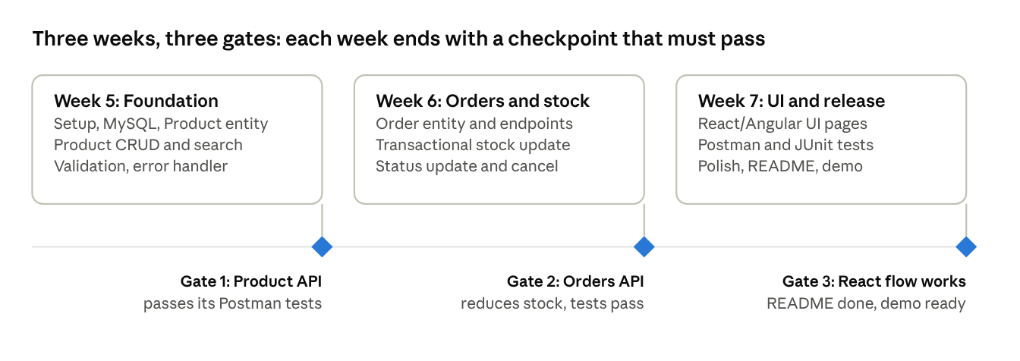
Week 5 to 7 roadmap · 3 phases, 3 gates
A gate is a short demo that a trainer or peer reviews before the next week starts; a learner who misses a gate finishes it before moving on.
Day | Focus | Output to show
1 | Generate project (Web, JDBC, MySQL, Validation) and add hibernate-core and spring-orm; create Git repo and shopsmart_db | App starts and connects to MySQL
2 | products table, Product entity, ProductDao | Table created; sample products inserted
3 | ProductService and ProductController with DTOs: create, get, list | Create and list work in Postman
4 | Update, delete, search with q and pagination | Search and paging work
5 | Bean Validation and GlobalExceptionHandler for products | Gate 1: Product API passes T-01 to T-04
6 | orders table, Order entity, OrderStatus enum, OrderDao | Table created with foreign key
7 | placeOrder with stock check and @Transactional | Order saved, stock reduced
8 | Order list with status filter, order detail | List and detail work
9 | Status update and cancel with stock return; @Version on Product | Invalid jumps return 400
10 | Mockito unit tests for the services and Postman tests T-05 to T-12 | Gate 2: Orders API reduces stock, tests pass
11 | React SPA (Vite) or Angular setup, routing, API client, product list with search | Products show in the browser
12 | Add and edit product forms | Create and edit from the UI
13 | Order form with live total; orders table | Place an order from the UI
14 | Status buttons, cancel, error banners, responsive CSS | Full flow works on a phone-width screen
15 | Bug fixes, README, table diagram, demo rehearsal | Gate 3: demo ready

14. Deliverables, Evaluation and Stretch Goals
Deliverables
- Git repository with the Spring Boot project and the React SPA / Angular app in separate folders, and weekly commits.
- schema.sql (and optional data.sql) that creates products and orders.
- Postman collection and environment exported as JSON.
- README with setup steps, the two-table diagram, the API list and screenshots.
- A 10-minute demo: add a product, order it, show stock drop, cancel, show stock return, and show one error response.
Evaluation rubric (100 marks)
Criterion | Marks | What the reviewer looks for
Database design | 10 | Correct types, primary keys, foreign key, CHECK constraints, sensible indexes
Product API | 15 | Full CRUD, search, pagination, DTOs, correct status codes
Order API and transaction | 20 | Stock reduced and restored correctly, price snapshot, rollback on failure
Validation and errors | 10 | Bean Validation, one JSON error format, no stack traces in responses
React SPA / Angular UI | 20 | Working screens for products and orders, loading and error states, responsive layout
Testing | 15 | Postman tests T-01 to T-12 and at least four Mockito service unit tests
Code quality and README | 10 | Layered packages, constructor injection, readable names, clear README
Stretch goals, in suggested order
- Add an order_items table so one order can hold several products.
- Add a categories table and a category filter on the product list.
- Keep a cart in the React SPA / Angular app (localStorage) and check out in one request.
- Add Spring Security with login and roles (customer and admin) and protect the product-management endpoints.
- Add Swagger/OpenAPI documentation with springdoc-openapi.
- Run MySQL and the app with Docker Compose.
From monolith to services (discussion). Products and Orders are already separate packages, so they are the natural split. The costs a learner should name: the foreign key from orders to products becomes a plain product id and a network call, and the single transaction that reduces stock and saves the order must become a coordinated sequence with a way to undo it. That is why the course starts with the monolith.

